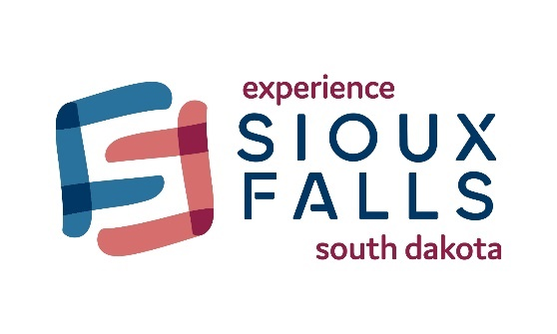
Group Tour Restaurants Available
Looks Marketplace
Looks has been the premier meat counter since 1883. Now, Looks has expanded to include a bakery, coffeeshop, butcher shop, cheese and charcuterie as well as a brewery and full-service restaurant.
500 E 69th St. Sioux Falls, SD 57108
605.336.3104
https://www.looksmarket.com/

Granite City Food & Brewery
Casual chain eatery with an American comfort-food menu plus craft beers brewed on-site.
2620 S Louise Ave. Sioux Falls, SD 57106
605.362.0000
https://www.gcfb.com/location/sioux-falls-south-dakota/

ROAM Kitchen + Bar
ROAM features a rustic scratch kitchen focused on woodfire cooking, extensive bourbon, beer, and wine offerings.
4525 W Empire Pl. Sioux Falls, SD 570106
605.215.0020
https://www.roamkitchen.com/

Cracker Barrel Old Country Store
An American chain of restaurant and gift stores with a southern country theme.
2409 S Shirley Ave. Sioux Falls, SD 57106
https://www.crackerbarrel.com/Locations/States/sd/sioux-falls/445
1.800.333.9566
grouptours@crackerbarrel.com
Crooked Pint Ale House
Warm welcoming atmosphere is known for a delicious menu of traditional pub foods including their award-winning Lucy, Pot pies, and Reubens. Great variety of local brews on tap.
2020 W Russel St. Sioux Falls, SD 57104
605.331.2050
https://www.crookedpint.com/sioux-falls/

McNally’s Irish Pub
With rich warm wooden details lit by reflective copper ceilings, lively music and laughter, this restaurant serves up a place to connect that’s open to the public, yet personal.
6211 S Old Village Pl. Sioux Falls, SD 57108
605.271.7170
https://mcnallysip.com/

IF IN NEED OF ANY OTHER PLACES TO EAT HERE ARE A FEW LINKS TO CONSIDER:

Facebook Group
https://www.facebook.com/groups/1341017736236591/

Experience Sioux Falls
https://www.experiencesiouxfalls.com/food-drink/restaurants

